Waitress review – bittersweet Broadway musical served warm in the West End
3/5stars3 out of 5 stars.

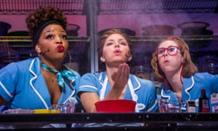
Adelphi, London
Based on Adrienne Shelly’s film and scored by Sara Bareilles, the New York hit arrives in London in a lively production.
Flour power … Marisha Wallace as Becky, Katharine McPhee as Jenna and Laura Baldwin as Dawn in Waitress. Photograph: Tristram Kenton/The Guardian
Billed as the first Broadway musical with an all-female creative team, this show gradually won me over. It derives from a 2007 movie written and directed by the late Adrienne Shelly and is a mix of realistic story and wish-fulfilling fable blessed with a punchy score by Sara Bareilles. With 9 to 5 The Musical installed on the opposite side of the road, it suggests London’s Strand is currently the home of cheerful liberation.
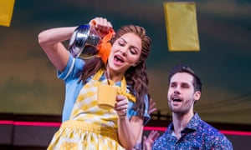
Initially, the show struck me as raucous and improbable. Bareilles’ lyrics often get lost under an over-loud onstage band and I couldn’t wholly believe in the plight of the pregnant protagonist, Jenna, a waitress and classy pie cook in a typical American diner. Why, I wondered, did she put up with a violently abusive husband who appropriated all her tips? But I found myself warming to Jessie Nelson’s book and to the vigour of the songs.
The performances, in Diane Paulus’s lively production, are very much part of the show’s appeal. Katharine McPhee, from the original New York cast, endows Jenna with a vulnerability, kindness and inbuilt sadness that only finds release in her extramarital fling: she also delivers her big climactic solo with real verve. But the show is a tribute to female solidarity and McPhee is well supported as fellow-waitresses by Marisha Wallace as the bawdy Becky – who says of her own sexual neglect that “it’s so quiet down there you can hear an echo” – and by Laura Baldwin as the slowly rising Dawn, who eventually discovers the delights of orgasmic rapture. Jack McBrayer as Laura’s geeky partner, with a mouthful of teeth that make him look like an animated rocking horse; David Hunter as Jenna’s nervous lover; and Shaun Prendergast as a dyspeptic fairy godfather lend weight to a show that has a fair share of schlock but a genuinely warm heart.

