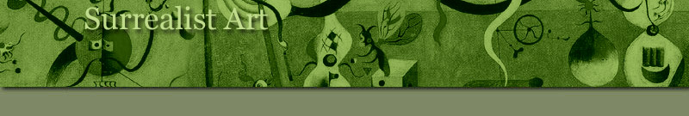
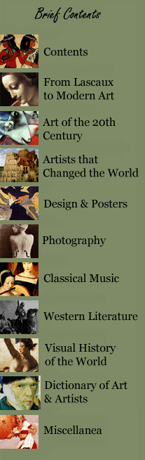
Art of the 20th Century
A Revolution in the Arts
 | Art Styles in 20th century Art Map
 | The Great Avant-garde Movements
Surrealist Art  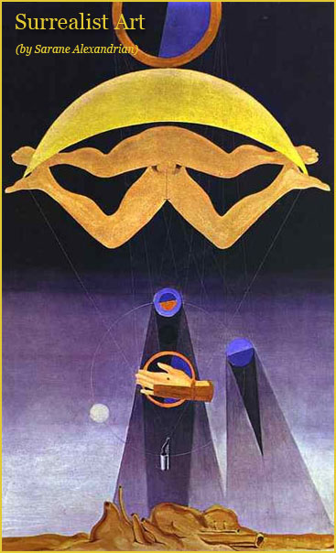 | Preface  CHAPTER ONE  Precursors  CHAPTER TWO  Anti-art  CHAPTER THREE  Conquest of the marvellous  CHAPTER FOUR  Surrealism and painting  CHAPTER FIVE  Towards a revolutionary art  CHAPTER SIX  Across the world  CHAPTER SEVEN  The object  CHAPTER EIGHT  Festivals of the imagination  CHAPTER NINE  In the United States  CHAPTER TEN  Surrealist architecture  CHAPTER ELEVEN  The post-war period  CHAPTER TWELVE  Occultation

*
see also:
Surrealism - 1924
Max Ernst "A Week of Kindness" (A surrealistic novel in collage)
EXPLORATION: Rene Magritte "Thought rendered visible"
EXPLORATION: Salvador Dali
EXPLORATION: Surrealism "The Dream of Revolution"
*
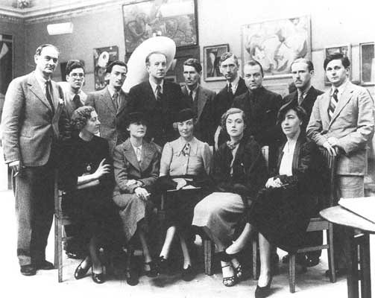
'International Surrealist Exhibition', New Burlington Galleries, London, 1936.
Standing left to right: Rupert Lee, Ruthven Todd, Salvador Dali, Paul Eluard, Roland Penrose, Herbert Read, E.L.T. Mesens, George Reavey and Hugh Sykes Williams.
Seated left to right: Diana Brinton Lee, Nusch Eluard, Eileen Agar, Sheila Legge and an unidentified friend of Dali
 | CHAPTER E I G H T
Festivals of the imagination
Kurt Seligmann
Leonora Carrington
Richard Oelze
Dora Maar
Esteban Frances
Gordon Onslow-Ford
Kay Sage
Brassai
Valentine Hugo
Jean Hugo
Jacqueline Lamba
*
See on the next page: Intellectual heroes of the surrealists :
Hegel, Sade, Baudelaire, Freud, Novalis, Lautreamont, Helene Smith,
Pancho Villa, Paracelsus
 | The surrealist artists did not confine their originality to their works : it was also evident in their methods of presentation. They always took the view that one-man and group shows should be something more than a series of paintings displayed on a gallery wall; each of their shows was embellished and given individuality, at least in the catalogue, by some new poetic discovery. They could imagine nothing more boring than the usual long line of visitors to a museum walking slowly and impassively past a collection of works of art.
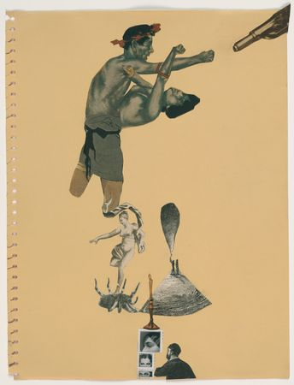  Cadavre Exquis, Oscar Dominguez,  Esteban Frances,  Marcel Jean and Remedios Varo  Untitled  1935 | For them, an exhibition was an opportunity to invite the public to a festival of the imaginary which would excite and confuse them, so that all taking part would be torn between amusement and anger, enthusiasm and indignation. It was a matter of creating a stimulating environment, an atmosphere which would enhance the spectator's receptiveness and arouse in him at the same time laughter, revulsion and desire, so that he was bound to approach the painting and sculpture in a state of emotional disturbance.  When he opened the Galerie Gradiva in the Rue de Seine in 1937, Breton had already hopes of making it 'a place from which it may be possible to overcome the retrospective viewpoint that people are accustomed to adopting with regard to true creativity in the arts', in other words, 'a timeless place, no matter where, so long as it is outside the world of reason'. It would also contain books, but 'the shelves to hold them must really be rays of sunlight' (the French word rayon means both 'shelf and 'ray'). All the painters in his circle helped Breton to do up the building : Duchamp designed a door in the shape of a double human silhouette, while Tanguy, Paalen and others decorated the mouldings with emblems.  The 'Exposition Internationale du Surrealisme' which was held at the Galerie des Beaux-Arts in Paris in January 1938 provided an opportunity for the movement to make a collective statement which outdid anything that it had hitherto undertaken. The visitor's first surprise was in the courtyard, where he encountered Dali's Kainy Taxi, a ramshackle vehicle inside which rain poured down on two dummies'a blonde covered with snails and a chauffeur with a shark's head. Next the visitor entered the Rue Surrealiste, a long corridor with street signs marking out the different sections; these were given either the names of actual streets of historical significance - the Rue de la Vieille-Lanterne, where Nerval committed suicide, the Rue Yivienne where Lautreamont lived - or names which were purely imaginary : Rue de Tous-les-Diables (All Devils' Street), Rue Faible (Weak Street), Rue de la Transfusion-du-Sang (Blood Transfusion Street), Rue Cerise (Cherry Street), etc.

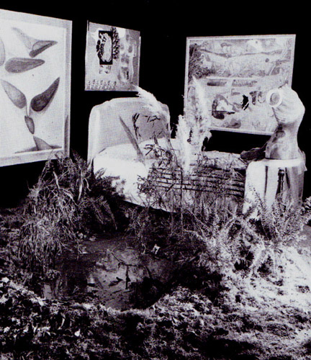
'Exposition Internationale du Surrealisme',
Galerie des Beaux-Arts, Paris 1938 : the pool ; one of the four beds ;
The Horoscope, an object by Marcel Jean ; paintings by Paalen, Penrose and Masson
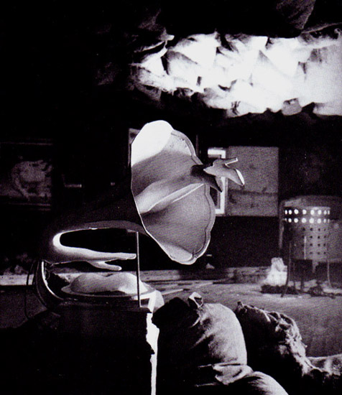
'Exposition Internationale du Surrealisme',
Galerie des Beaux-Arts, Paris 1938 : Never,
an object by Dominguez ; the brazier ; the sacks of coal
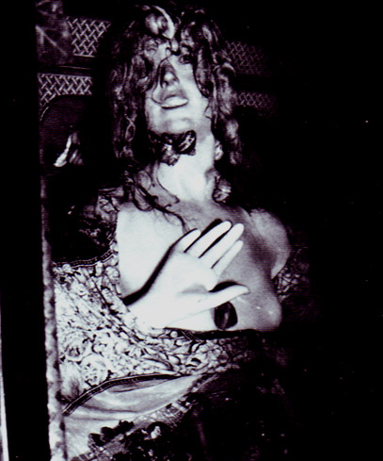
Dali
Kainy Taxi
 | At intervals along this corridor, visitors were received by shop window dummies of women - mannequins - each one created and clothed by one of the painters. Max Ernst's mannequin was dressed in black veils and trampled the figure of a man underfoot; the one designed by Paalen was covered in moss and fungi and had a bat on her head; Man Ray's wept crystal tears, and wore a headdress of pipes with glass bubbles emerging from them; Duchamp's figure wore a man's jacket with a red electric light bulb in the breast pocket in place of a folded handkerchief. The most spectacular of all was Masson's Girl in a black, gag with a pansy mouth ; she had her head in a wicker cage and wore a cache-sexe covered with glass eyes.
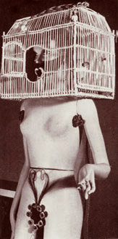  Masson  Girl in a black, gag with a pansy mouth  Mannequin for the  Exposition Internationale du Surréalisme,  Paris, 1938 | 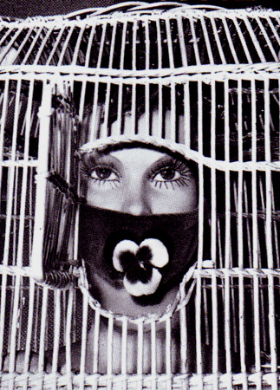  Masson  Girl in a black, gag with a pansy mouth

Then the visitor reached the central hall, which had been designed with masterly success by Marcel Duchamp, the 'generator-arbiter' of the exhibition; Breton and Eluard were the 'organizers', with Man Ray as 'master of the lights', Paalen in charge of 'water and brushwood', and Dali and Max Ernst as technical advisers. The hall was arranged to resemble a grotto - the floor was covered with a carpet of dead leaves; 1,200 sacks of coal hung from the ceiling. In the middle stood an iron brazier, symbolizing the gathering of friends round a hearth, and in each of the four corners an enormous bed offered an invitation to dreams and love. Part of the area was cut off from the rest by a pool with water-lilies and reeds. A number of astonishing objects, such as Seligmann's Ultra-furniture (a stool made of four female legs) contributed to the spectacular effect.
On the opening day, after a speech made by Paul Eluard wearing a frock coat, a dancer gave a performance entitled The Unconsummated Act, which she interpreted first on the edge of the pool, and then in it. The atmosphere was pervaded with 'scents of Brazil': the smell of roasting coffee. It was announced that the automaton Enigmarelle would walk across the Gallery 'in false flesh and false bones', but this was only a hoax designed to arouse a sense of anticipation. A 'concise dictionary of surrealism' (Dictionnaire abrege du surrealisme), which appeared at the time of the exhibition, contained some strange definitions (lie - a parasol on a muddy road; Moon - a marvellous glazier; Rape - a love of speed), and a curious comment on himself by Breton : 'His dearest wish was to belong to the family of the great undesirables'. It caused a great sensation, but the remarks of the press showed that the underlying reason behind this behaviour was sometimes misunderstood. It was less that the surrealists were set on originality for its own sake than that they wished to introduce a sense of adventure into the confrontation between the spectator and the work of art.
At about this period, a number of newcomers joined the ranks of the originators of surrealism. Max Ernst had met Leonora Carrington, a young upper-class Englishwoman, in London, and from 1937 until 1940 she lived with him at Saint-Martin-d'Ardeche, in a house which he decorated himself with frescoes and bas-reliefs. The black humour and strange inventiveness of her fantastic stories, such as La Maison de la Peur (1938), is echoed in her paintings, among them Lord Candlestick's repast (1938) and What shall we do tomorrow, Aunt Amelia ? (1938). Whimsically confused memories of her own earlv life, such as the scenes in which she depicts herself as a white horse, lend particular charm to her painting.
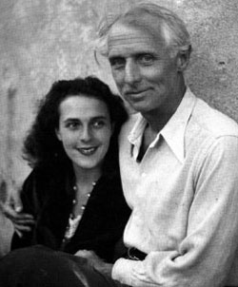  Leonora Carrington and Max Ernst | 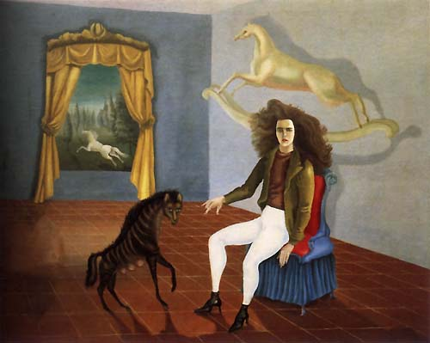  Leonora Carrington  Self-Portrait  1937–38

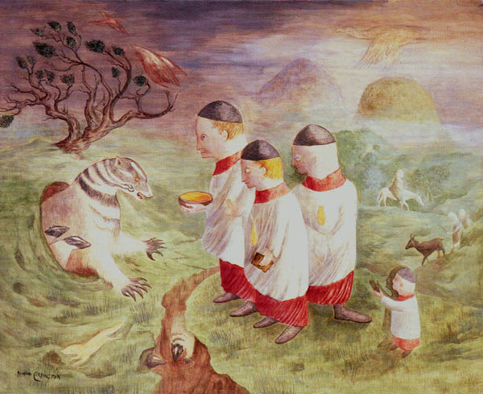
Leonora Carrington
Big Badger Meets the Domino Boys
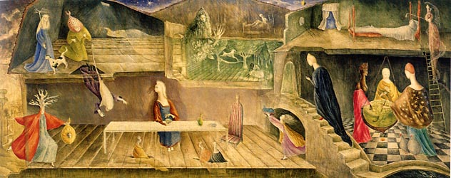
Leonora Carrington
The House Opposite
1945
 | Richard Oelze, a German painter who had studied at the Bauhaus in Weimar, came to Paris in 1932 and threw in his lot with the surrealists. In his paintings he managed to create unexpected effects from day-to-day realities, as in Expectation (1935) and The Dangerous Desire (1936). He made use of 'frottage' in a very individual way, and although he was obliged to give up his work for ten years, he took up his experiments after the war along exactly the same lines.
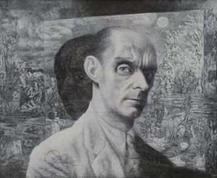  Richard Oelze | 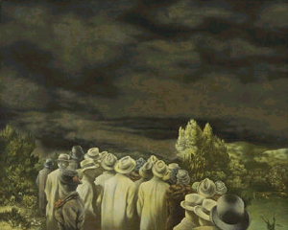  Richard Oelze  Expectation

 | Valentine Hugo began her career with a series of twenty-four wood engravings (1926) for an edition of Romeo and Juliet designed by Jean Hugo. She then attracted attention with a number of lithographic portraits, of Raymond Radiguet, Princess Bibesco, Georges Auric, and others. She took part in the surrealist movement from 1930, and was noted particularly for her illustrations, in which she created an intangible world with pastels and gouaches, as in the illustrations for Les Chants de Maldoror (1932-3) and Achim von Arnim's Contes bizarres (1933). For Paul Eluard's Les Animaux et leurs bomines (1937) she used drypoint. She also produced a series of allegorical paintings based on the Rimbaud legend.
Valentine Hugo
(French Painter, 1887-1968)
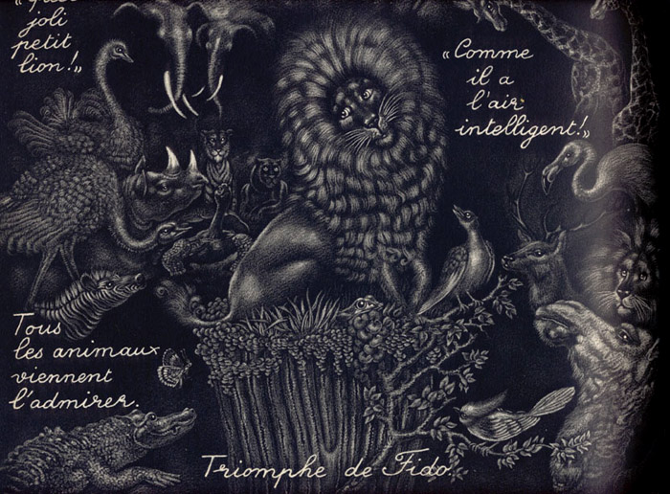
Valentine Hugo
Premier tirage des "manière noire"
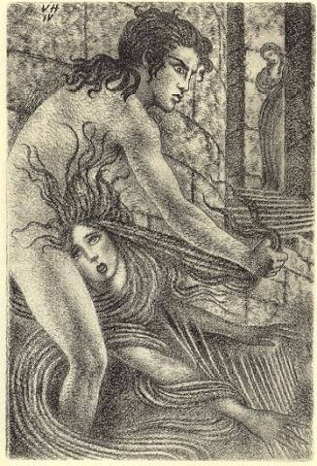  Valentine Hugo  Marquis de Sade, Eugénie de Franval | 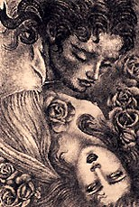  Valentine Hugo  Marquis de Sade, Eugenie de Franval
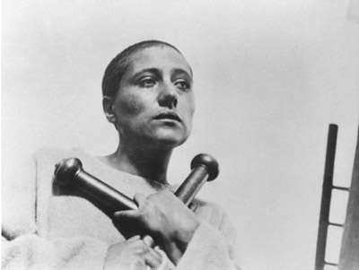
Valentine Hugo
La Passion de Jeanne D'Arc
Editor: Carl Theodor Dreyer; art directors: Hermann Warm and Jean Hugo;
costume designer: Valentine Hugo
Jean Hugo
(French, 1894-1984)

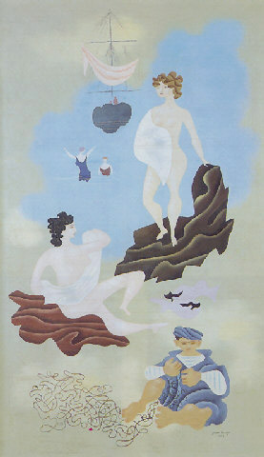  Jean Hugo  Les plaisirs de la plage 1928 | 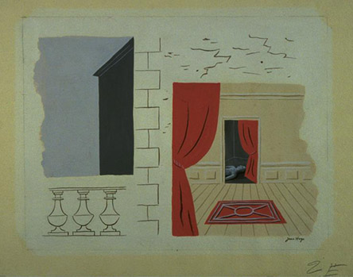  Jean Hugo  La Mort

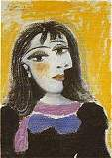  Pablo Picasso  Dora Maar | Dora Maar was a painter and photographer of Yugoslav origin; she was for some time Picasso's 'muse', and then joined the surrealists from 1935 to 1937, but later turned her attention towards mysticism. Maurice Henry came into the movement in 1932 and produced humorous drawings, mainly on the theme of ghost stories, which foreshadowed the graphic experiments of his later albums Les Metamorphoses du Vide and Les 32 positions de l'Androgyne. Esteban Frances was a Spanish painter whose use of the technique of 'grattage' resulted in a pure automatism which was much admired. Gordon Onslow-Ford, an English painter who had spent some time in the Royal Navy, became interested in surrealism in 1937; his subsequent development soon led him towards abstraction.
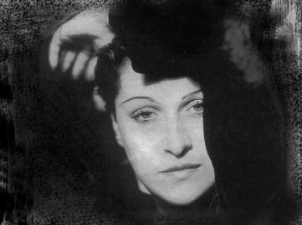  Man Ray  Dora Maar | 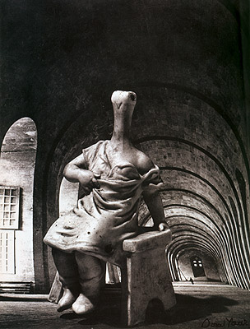  Dora Maar  29. rue d'Astorg  1936

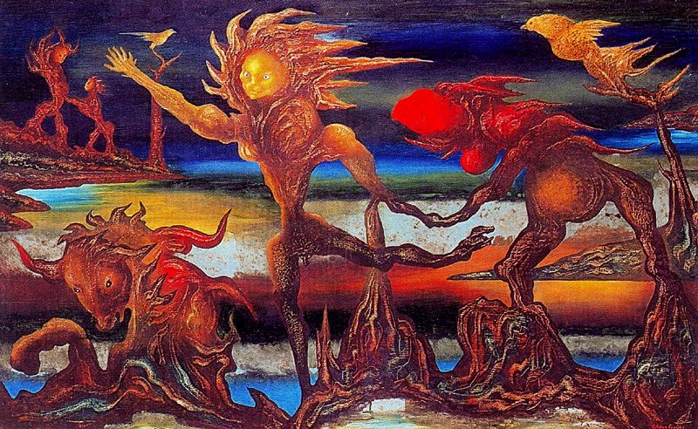
Esteban Frances
El lago
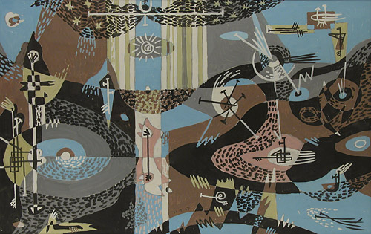
Gordon Onslow-Ford
Future of the Falcon
 | Kurt Seligmann was born in Switzerland, where he had made a collection of documents concerning witchcraft and had written a history of magic. He exhibited at Basle and Berne, and then published a series of fifteen etchings entitled Cardiac Protuberances (1934). While working with the surrealists, he was particularly interested in creating objects, and many of his drawings were inspired by heraldic emblems. In some of his paintings he gives a highly mannerist interpretation of classical mythology, using automaton-like figures.
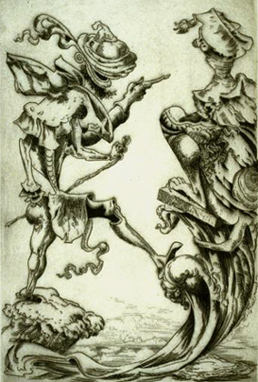  Kurt Seligmann  The Riddle, pl. 4 from the series "Oedipus" | 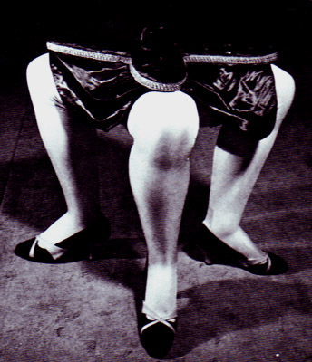  Kurt Seligmann  Ultra-furniture

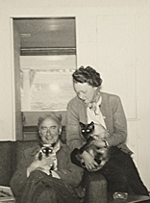  Kay Sage and Yves Tanguy | Kay Sage was American and had studied painting in Milan, where she held an exhibition of abstract works in 1926. She arrived in Paris in 1937, and concentrated on creating representations of the fantastic; she attracted the attention of Yves Tanguy, whom she married, and with whom she returned to live in the United States in 1939. Her treatment of imaginary towns was particularly striking, as in Tomorrow is never (1955, New York, Metropolitan Museum).  Minotaure, founded by Albert Skira, had become surrealism's official publication. The 'review with a beast's head' first appeared in May, 1933, the month which saw the last issue of Le Surrealisme аu service de la Revolution. On account of its luxurious format and its wit, Minotaure provided an opportunity for the beauty of surrealism to be defined more clearly than ever before. At first, under Teriade's editorship, it dealt with classical and modern art in an eclectic manner, but Breton soon imposed on it his own particular line.
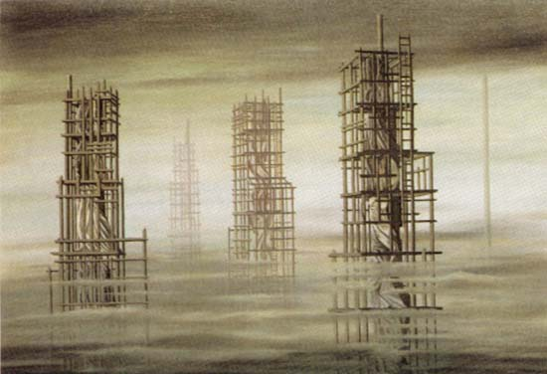
Kay Sage
Tomorrow is never
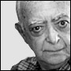  Brassai | Minotaure set out to stimulate interest in the unexpected in art, the study of rare documents, anything off the beaten track. In their photographs, Brassai, Man Ray, Raoul Ubac and Dora Maar succeeded in using reality as a trap in which to capture the marvellous. The first signs of surrealism in the past were outlined in articles on the baroque, Gericault, Botticelli, Urs Graf, Uccello and Piero di Cosimo. Maurice Heine, the defender and exponent of the ideas of the Marquis de Sade, contributed items on the illustrations of the English Gothic novels and those of the works of Sade's contemporary Restif de la Bretonne, in which the engraver Binet depicted an idealized 'Sylphide' type of woman; on Jean Duvet's Apocalypses; and on the Tibetan gods.  The 'united front of poetry and art' which the surrealists sought to establish was given support in Paul Eluard's article 'Physique de la poesie', a study of painters who illustrated the works of poets. By means of his collection of postcards, 'those treasures of nothingness', Eluard also helped to draw attention to minor art forms which throw unexpected light on the meaning of beauty. Breton showed a collection of mediums' drawings, while Peret contributed poems singing the praises of armour, ruins and automatons.
  Many surrealist artists had great interest in the Marquis de Sade. The first Manifesto of Surrealism (1924) announced that "Sade is surrealist in sadism." Guillaume Apollinaire found rare manuscripts by Sade in the Bibliothèque Nationale in Paris. He published a selection of his writings in 1909, where he introduced Sade as "the freest spirit that had ever lived." Sade was celebrated in surrealist periodicals. In 1926 Paul Eluard wrote of Sade as a "fantastique" and "revolutionary." Maurice Heine pieced together Sade's manuscripts from libraries and museums in Europe and published them between 1926 and 1935. Extracts of the original draft of Justine were published in Le Surréalisme au service de la révolution.
  The surrealist artist Man Ray admired Sade because he and other surrealists viewed him as an ideal of freedom. According to Ray, Heine brought the original 1785 manuscript of 120 Days of Sodom to his studio to be photographed. An image by Man Ray entitled Monument à D.A.F. de Sade appeared in Le Surréalisme au service de la révolution. (From Wikipedia)
  see Salvador Dali Illustrations:
  Marquis de Sade
  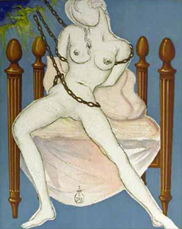
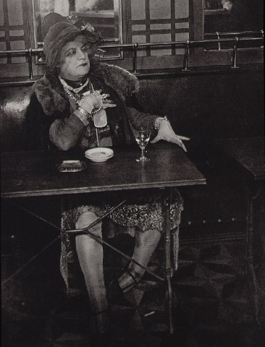
Brassai
"Bijou" of the Montmartre cabarets
From "Paris by Night"
1933
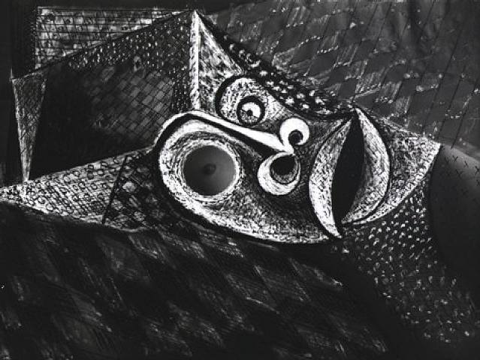
Brassai
Transmutation NO. VIII "Tentation de Saint Antoine"
1934-50
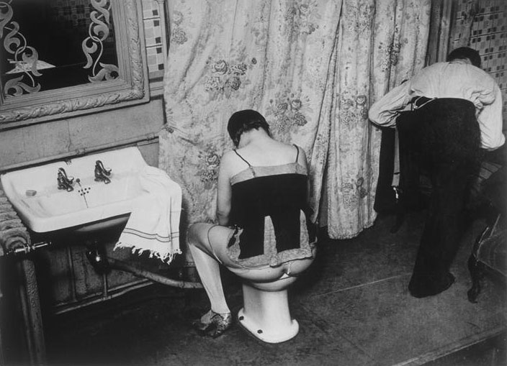
Brassai
Washing in Brothel
1932
Brassai
(Encyclopaedia Britannica)
born September 9, 1899, Brassó,Transylvania, Austria-Hungary [now Romania]
died July 8, 1984, Eze, near Nice,France
Original name Gyula Halász , French Jules Halasz Hungarian-born French photographer, poet, draughtsman, and sculptor, known primarily for his dramatic photographs of Paris at night.His pseudonym, Brassaï, is derived from his native city.
Brassaï trained as an artist and settled in Paris in 1924. There he worked as a sculptor, painter, and journalist and associated with such artists as Pablo Picasso, Joan Miró, Salvador Dalí, and the writer Henry Miller. Although he disliked photography at the time, he found it necessary to use it in his journalistic assignments and soon came to appreciate the medium's unique aesthetic qualities.
Brassaï's early photographs concentrated on the nighttime world of Montparnasse, a district of Paris then noted for its artists, streetwalkers, and petty criminals. His pictures were published in a successful book, Paris de nuit (1933; Paris After Dark, also published as Paris at Night), which caused a stir because of its sometimes scandalous subject matter. Hisnext book, Voluptés de Paris (1935; “Pleasures of Paris”), made him internationally famous.
When the German army occupied Paris in 1940, Brassaï escaped southward to the French Riviera, but he returned to Paris to rescue the negatives he had hidden there. Photography on the streets was forbidden during the occupation of Paris, so Brassaï resumed drawing and sculpture and began writing poetry. After World War II, his drawings were published in book form as Trente dessins (1946; “Thirty Drawings”), with a poem by the French poet Jacques Prévert . Brassaï turned again to photography in 1945, and two years later a number of his photographs of dimly lit Paris streets were greatly enlarged to serve as the backdrop for Prévert's ballet Le Rendez-vous. Many of Brassaï's postwar pictures continued the themes and techniques of his early work. In these photographs Brassaï preferred static over active subjects, but he imbued even themost inanimate images with a warm sense of human life.
The Museum of Modern Art in New York City held a retrospective exhibition of Brassaï's work in 1968. His Henry Miller, grandeur nature (Henry Miller: The Paris Years) was published in 1975, and a book of his photographs entitled The Secret Paris of the 30's in 1976. Artists of My Life, a collection of his photographic and verbal portraits of well-known artists, art dealers, and friends, was published in 1982.
 | Finally, Minotaure decided to demonstrate that even fashion was a subject worthy of the attention of poets and painters, and it published some extracts from La Derniere Mode, the women's magazine founded by Mallarme. Crevel discussed the connection between fashion and fantasy, while Tzara, who had made his peace with Breton after the Second Manifests and now supported surrealism with the same zeal with which he had launched dadaism, wrote an unusual article on the unconscious mechanisms governing a woman's choice of a hat : 'D'un certain automatisme du gout'. Dali expounded a theory of the 'new colours of spectral sex-appeal'.
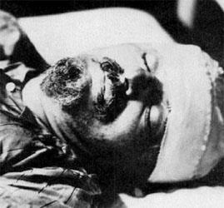  Trotsky dead | In the spring of 1938, before leaving for a trip to Mexico, Breton addressed the readers of his review as follows : 'Follow Minotaure, and in addition : beware of imitations, rubbish from the second-hand market, hot-air balloons.'  In Mexico he met Leon Trotsky and the painter Diego Rivera, who had designed the impressive frescoes on the Palacio Nacional and many other public buildings. With them he wrote the manifesto 'For an independent revolutionary art' (Pour un art revolutionnaire independent), which set out in eloquent terms all the ideas he had fought for over the years. In the face of the current threats of war and oppression, Breton demanded an 'artistic opposition' to be manned by all the available artists in the world. But he emphasized that such an opposition would be effective only if the powers of imagination were allowed free rein : 'To those who would persuade us, now or in the future, that art should submit to a discipline which we consider totally incompatible with its methods, we reply with an unconditional refusal, and our determination to adhere to the principle : all freedom in art.'

With this in mind, Breton created, on his return to Paris in July, 1938, the International Federation of Independent Revolutionary Art (F.I.A.R.I.), whose short-lived publication Cle had as its editorial secretary Maurice Nadeau, who was later to write a Histoire du surre'alisme.
The Second World War brought this spiritual quest to a temporary halt, and gave the surrealists an opportunity to define clearly the role of art in such circumstances. At the end of 1940 they gathered at the Chateau Air-Bel, near Marseilles, under the auspices of the American Committee for Aid to Intellectuals; there, despite the uncertainty and disturbance they all felt, they set about inventing a new set of playing-cards.
Breton had stated : 'Historians of the playing-card all agree that throughout the ages the changes it has undergone have always been at times of great military defeats'. They therefore evolved a system in which the four suits were replaced by symbols representing their chief preoccupations : Love (Flame), Dream (Black Star), Revolution (Wheel and blood), and Knowledge (Keyhole). The cards consisted of Ace, Genius, Siren, Magus, Ten, etc., and portrayed some of the intellectual heroes of the surrealists : Hegel, Sade, Baudelaire, Freud, Novalis, Lautreamont, Helene Smith (the medium), etc. These cards were made by Frederic Delanglade from designs by Jacqueline Lamba, Andre Breton, Andre Masson, Victor Brauner, Wifredo Lam, Jacques Herold and Oscar Dominguez. They illustrate the desire constantly proclaimed by the surrealists to preserve, in the face of everything, even in the most tragic circumstances, the delicate flower of inspiration which is the chief adornment of life.
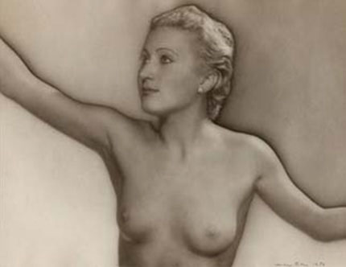  Man Ray  Jacqueline Lamba | Jacqueline Lamba  (1910 - 1993)  Studied decorative arts in Paris. Married Andre Breton in 1934 and was the subject of many of his poems of those years including "La Nuit de Tournesol' which anticipated their meeting.  Began exhibiting objects and drawings with the Surrealists. Arriving in New York, she developed automatism into a series of intense prismatic paintings close in spirit to the abstract work of Matta and Masson.  Separated from Breton in 1943 and later married the American sculptor and photographer David Hare.  First one-woman exhibition at the Norlyst Gallery, New York, in 1944. Also exhibited at the San Francisco Museum of Modern Art (1946) and Galerie Pierre, Paris (1947).  In her later years, lived as a recluse in her Paris studio. Developed Alzheimer's Disease in the last five years of her life.
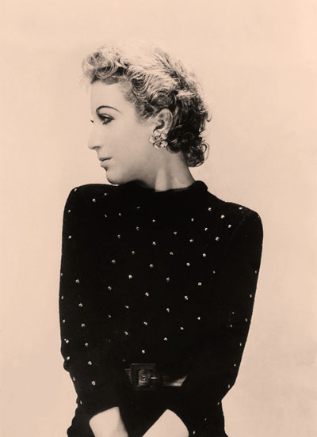  Jacqueline Lamba | 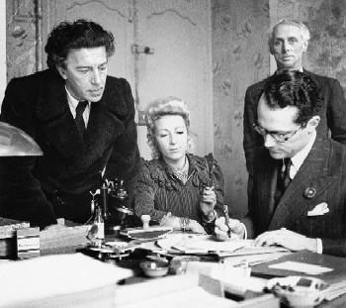  Andre Breton,  his wife, Jacqueline Lamba,  and Max Ernst
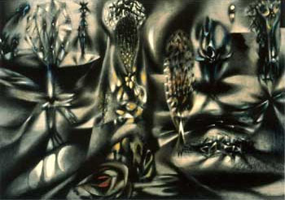  Jacqueline Lamba  In Spite of Everything  1942 | 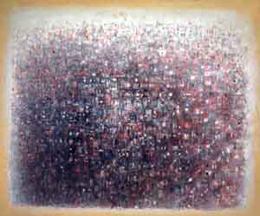  Jacqueline Lamba  Ville-Paris-Panorama
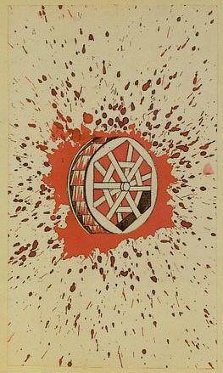  Jacqueline Lamba  Le jeu de Marseille:  Projet de carte:  As de la Révolution; la roue (et sang) | See on the next page:  Le jeu de Marseille  Intellectual heroes of the surrealists :  Hegel, Sade, Baudelaire, Freud, Novalis,  Lautreamont, Helene Smith,  Pancho Villa, Paracelsus  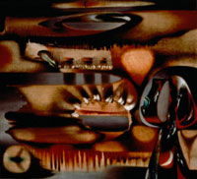  Jacqueline Lamba  Behind the Sun  1943
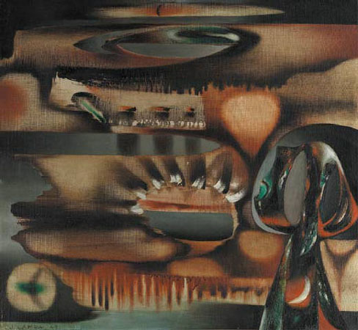
Jacqueline Lamba
Behind the sun

Αρχή φόρμας
Enter your search terms Submit search form
Web | www.all-art.org

Τέλος φόρμας



