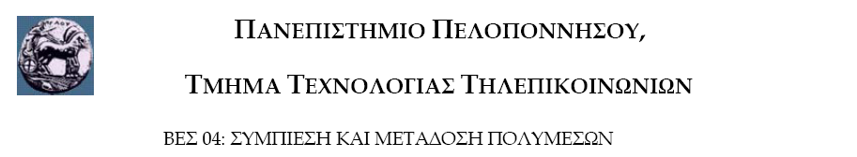

Εργαστηριακή Άσκηση 1: Μέτρηση Πληροφορίας

Η άσκηση αυτή έχει στόχο την κατανόηση των εννοιών πληροφορία, εντροπία και πλεονασμός και των
μαθηματικών τους περιγραφών.

Ημερομηνία Παράδοσης: μέχρι την ημέρα της τελικής εξέτασης

Δίνεται το παρακάτω κείμενο:
« in computer science and information theory data compression or source coding is the process of encoding information using fewer bits or other information bearing units than an unencoded representation would use through use of specific encoding schemes examples include the zip file format which also acts as an archiver storing many source files in a single destination output file and the gzip utility
as with any communication compressed data communication only works when both the sender and receiver of the information understand the encoding scheme for example this text makes sense only if the receiver understands that it is intended to be interpreted as characters representing the english language similarly compressed data can only be understood if the decoding method is known by the receiver
compression is useful because it helps reduce the consumption of expensive resources such as hard disk space or transmission bandwidth on the downside compressed data must be decompressed to be used and this extra processing may be detrimental to some applications for instance a compression scheme for video may require expensive hardware for the video to be decompressed fast enough to be viewed as it's being decompressed the option of decompressing the video in full before watching it may be inconvenient and requires storage space for the decompressed video the design of data compression schemes therefore involves tradeoffs among various factors including the degree of compression the amount of distortion introduced if using a lossy compression scheme and the computational resources required to compress and uncompress the data »

Να υλοποιήσετε συνάρτηση η οποία:

1) Να υπολογίζει την πιθανότητα εμφάνισης των συμβόλων: a, b, c, d, e, f, g, h, i, j, k, l, m, n, o, p, q, r, s, t, u, v, w, x, y, z.
Στον υπολογισμό των πιθανοτήτων να λάβετε υπ’ όψιν και τα κενά (space).

2) Να υπολογίζει την πληροφορία που μεταφέρουν τα ανωτέρω σύμβολα.

3) Να υπολογίζει τον αριθμό λέξεων στις οποίες εμφανίζεται κάθε σύμβολο.

