Dear West End Producer: ‘Why is there never any mention of backstage and production staff? Are we not dramatic enough?’
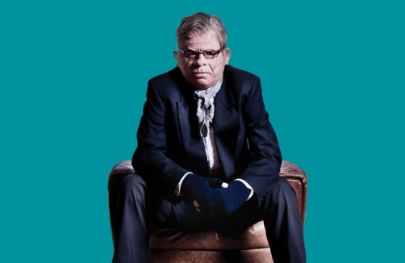
Of course you are dramatic enough. You are vital in the working of any theatre show. I, as most people did, started my theatrical career working backstage – and am only too aware of the hard jobs and integral role you all play in the creation of theatre. I agree that sometimes the limelight goes to actors and directors – the people that seem to be the ‘face’ of shows, but everyone knows that the real hard work happens backstage.
Now, I’m not writing this article to simply praise everyone who works backstage – I just think it’s about time we all show some thanks. Those lovely backstage people are the real people who live in a theatre. They arrive hours before any actors – checking the set and stage for problems, testing sound levels, setting wigs, washing stained shirts. Their job is never- ending, particularly on long-running shows with big companies and actors who leave skid marks in their show pants every night.
Most theatres will have a resident stage crew who know the workings of the theatre like the back of their hand. They will have been there for years – and seen all the various shows and different adaptations of the stage. They will have worked with wonderful companies of actors, and not so wonderful companies of actors. But they always remain professional, brilliant and make sure everyone is safe in their buildings.
There should never be a divide between production staff, backstage crew, wardrobe, dressers, sound and actors – they all work together to make any show possible. Theatre is a community, a place where everyone plays an important role – and this should never be forgotten. And so what if the show has a celeb in it? They are no more important than the brilliant assistant stage managers that set the props to allow that celeb to do their job. Every role in theatre relies on someone else.
So next time you see someone leaving the theatre by the stage door who isn’t an actor, talk to them, ask them what they do – you’d be surprised at how wonderful they are. They are the ones allowing the drama to happen on stage. I would love it if fans asked the backstage workers for autographs instead of the actors. Wouldn’t that be marvellous? And I’ve always thought that backstage workers have as much right to take a bow as the actors. Maybe it’s time to break the age-old tradition of curtain calls, and always include the backstage team from now on. So, on behalf of the theatre community and the audiences who don’t say it as much as we should – ‘thank you’ to all you brilliant, wonderful, patient, miraculous people who hide and work backstage and make theatre happen. After all, without you, the actors are merely naked mutes wandering around in the dark, dear.

